CHEMISTRY unit 3 RESEARCH ASSIGNMENT:

TYPE – RESEARCH

OUTCOMES TO BE ASSESSED:
Outcome 1: Investigating and Communicating

Outcome 2: Structure, Properties and Uses of Materials

Outcome 3: Interaction and Change

ESSENTIAL CONTENT - UNIT 3
The practice of chemistry
Chemical processes
Chemistry and Modern Lifestyles
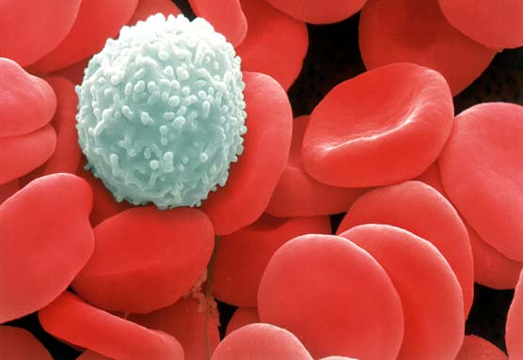

Overview: Blood Buffers / Ocean Acidification

The pH of the human blood must be maintained within certain limits for the body’s proper functioning. By far the most important buffer for maintaining acid-base balance in the blood is the carbonic acid-bicarbonate buffer. The series of interlinked equilibria shown above is central to the control of blood pH. As with all equilibria they respond to changes that are imposed in ways that can be predicted using Le Chatelier’s principle. During exercise the body must compensate for changes caused in CO₂ output and this has a direct impact on the buffering system. Ocean acidification has largely been ignored as global warming has taken centre stage. With a predicted fall in pH form the current 8.1 to 7.7 by 2100, what effect will this have on seafood stocks, particularly shellfish. The ocean absorbs approximately one third of the world’s CO₂ emission as the carbon sink, but can this go on forever. Two thirds of the Great Barrier relief have been affected by coral bleaching.

TASK:

Research the chemistry of this major blood buffering system and ocean acidification. You should incorporate your knowledge of Le Chatelier’s principle wherever appropriate. Use the stimulus questions to devise section headings and present as concise notes with appropriate content, illustration and animation in the sequence prescribed below:

- What is a buffer and describe the chemistry of buffers in general?

- Explain the chemistry of the carbonic acid-bicarbonate buffer system.

- When exercising the body’s CO₂ outputs are changed and the concentration of this gas in the blood changes likewise. Use Le Chatelier’s principle to explain how the body copes with these changes and the impact that this has on blood buffering.

- Describe the chemistry of the conditions known as “Acidosis” and “Alkalosis” and the body response to them.

- What is ocean acidification and how it is affected by rising CO₂ levels.

- Understand the main equations, using Le Chatelier’s principle predict the effects of rising CO₂ and its effect on the hydrogen and carbonate ions.

- Ocean pH has fallen approximately 0.1 since the Industrial Revolution, expand on this and what effect it is having on the ocean calcifiers.

- http://www.abc.net.au/news/2017-04-10/great-barrier-reef-severe-coral-bleaching-hits-two-thirds/8429662

- You will be assessed on your six-page A4 research document as well as your written answer to two “Open” validation questions that will be completed in class. You WILL be able to use your six-page A4 research document to help in completing the validation questions.

Outcome 1 aspect 4 Outcome 2 aspects 1,2,3 and 4

What needs to be in your folio for assessment? | Due date
▢ Six pages A4 notes ▢ Open ended question response

